

**CHALFONTS CONSERVATIVES**

Invite you to join us for dinner with our Guest Speakers

**DAVID LIDINGTON CBE MP**

Minister for the Cabinet Office & Chancellor of the Duchy of Lancaster

&

**THE RT. HON. DAME CHERYL GILLAN DBE MP**

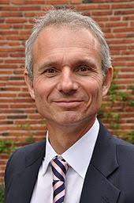 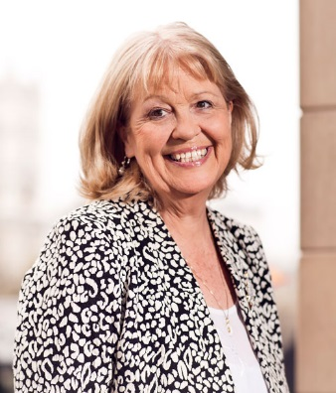

**FRIDAY 15th March 2019 7pm for 7.45pm**

GERRARDS CROSS GOLF CLUB

CHALFONT PARK, CHALFONT ST PETER SL9 0QA

**TICKETS £27.50**

CARVERY, DESSERT & COFFEE

SALMON OR VEGETARIAN OPTION ALSO AVAILABLE

(Please specify when booking if you would like an alternative option)

Dress: Lounge Suits Cash Bar

………………………………………………………………………………………………………………………

**THE CHALFONTS DINNER FRIDAY 15TH MARCH 2019**

I require …… tickets at £27.50 each and enclose my cheque for £……….… made payable to CACA.

Please send to Cllr Linda Smith at 11 Robins Orchard, Chalfont St Peter, SL9 0HQ

Telephone: 01494 874065 or Email: [lsmith@chiltern.gov.uk](mailto:lsmith@chiltern.gov.uk)

Name(s) ………………………………………………………………………………………………………………………..

Address ………………………………………………………………………………………………………………………..

E mail ………………………………………………………… Telephone number ……………………………..

***Please advise us of any allergies or dietary requirements***

Please note that to save on costs, physical tickets will not be issued.

If you cannot come but would like to make a donation, this would be gratefully received.