Chesham & Amersham Constituency Conservative Association
Chalfont St Peter Branch
Invite you to a
Curry Evening
on
Tuesday 14TH MAY 2019
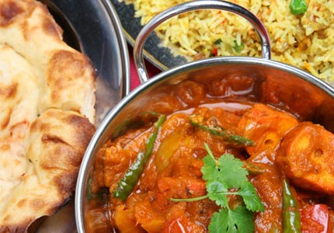
7.30pm
At
SPICE
10 Market Place, Chalfont St Peter SL9 9EA
Tickets: £17.50 for 2 Course Indian Meal plus Coffee
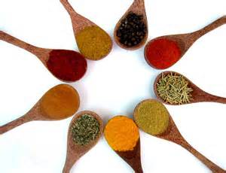
Starter, Main course, sides, bread – vegetarian option available (please state when booking if required)

Chalfont St Peter Branch Curry Evening – Tuesday 14TH MAY 2019

Please contact Cllr Linda Smith, 11 Robins Orchard, Chalfont St. Peter SL9 0HQ
Telephone 01494 874065 Email lsmith@chiltern.gov.uk
cheques payable to CACA
or BACS payments Account No. 21190989 Sort Code 40-17-69

I require ……………… places and I enclose my cheque for £ ………..
Please state any dietary requirements
Name ……………………………………….. Phone no …………………………………
Address ……………………………………………………………………………………….
……………………………………………………………………………………………….….
…………………………………………………… Email………………………………………

