
Chesham & Amersham Constituency Conservative Association
AMERSHAM BRANCH
Invites you to a
Summer Sundowner Barbeque
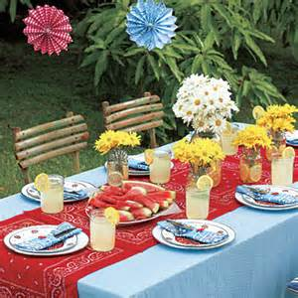

Saturday 6 July 2019 6.00pm until 10.00pm
at
122 Chestnut Lane, Amersham, HP6 6DZ
By kind invitation of Debbie and Richard Kenchington

Tickets: £20.00
Raffle and free glass of wine
-------------------------------------------------------------------------------------------------------------------------------
Amersham Branch Summer Sundowner Barbeque - Saturday 6 July 2019

Please save me ……. ticket(s) @ £20 each. Cheques made payable to Amersham Conservatives.
Send to: Liz Walsh 41 Oakfield Close Amersham HP6 5TA. Tel: 07831 267594.
Or transfer to Sort Code: 20-02-06. Account No: 53175863 Reference: Your surname. And be sure to confirm by emailing: liz.walsh@btinternet.com
Name …………………………………………………………………. Phone no …………………………………
Email ……………………………………………….. We will acknowledge receipt of payment by email.
Please state any dietary requirements
PLEASE RSVP BY 28 JUNE 2019

