Tree logo

**The Chalfonts Conservatives**

**Invite you to our**

**Christmas Party**

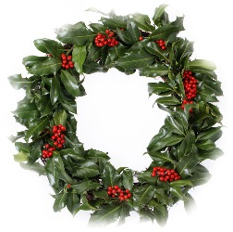

**Friday December 13th 2019**

**6.30pm - 8.30pm**

**Tickets £15**

**Fizz, wine and party food**

**In the presence of Rt Hon Dame Cheryl Gillan, DBE, MP and our County and District Councillors**



**At Hare Cottage, Harewood Road, Chalfont St Giles HP8 4UA**

**____________________________________________________________________**

**If you would like to join us please e-mail: martindale9@gmail.com with your details.**

**Payment by cheque to ‘CACA’ to**

**Martin Dale Hare Cottage Harewood Rd Chalfont St Giles HP8 4UA**

**BACS 20-02-06 account no 60255963.**

**Please quote your surname and ‘Chalfonts Xmas’ as a reference**